**Experiment No. 7**

**Aim**: Implement and evaluate Clustering Algorithms using languages like JAVA/ python/R.

**Theory :**

Step 1:Import necessary libraries and load the dataset.

Step 2: Choose the clustering algorithm and fit the model to the data.

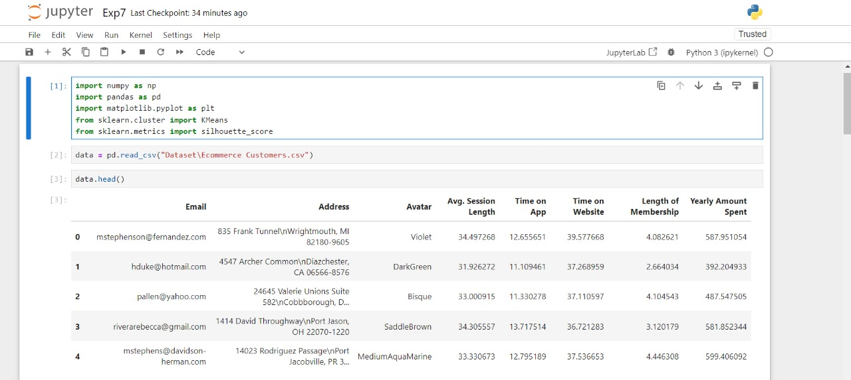

Step 3: Preprocess the data (if needed).

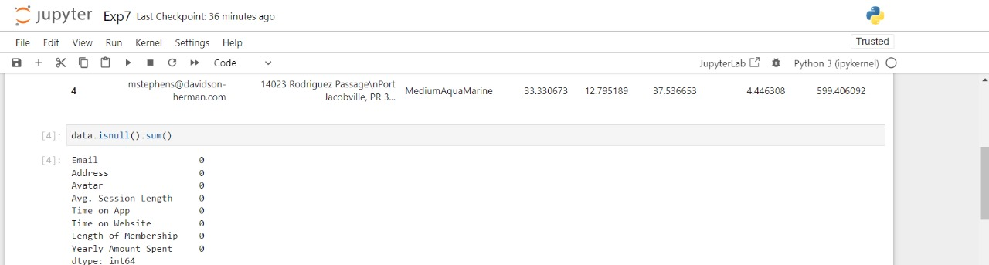

Step 4: Evaluate the clustering using the Silhouette Score.

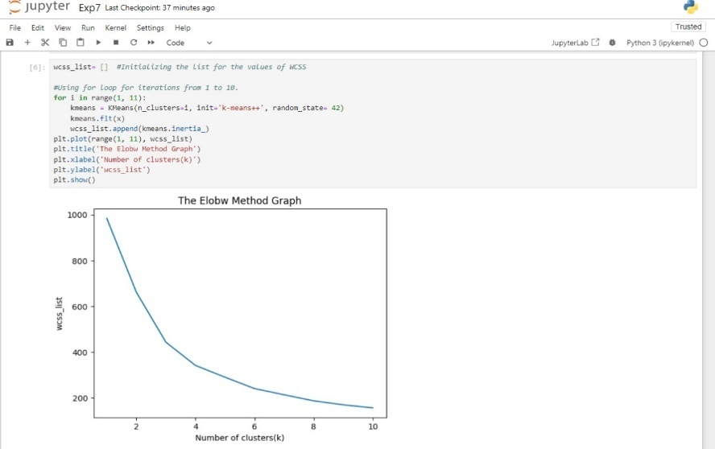

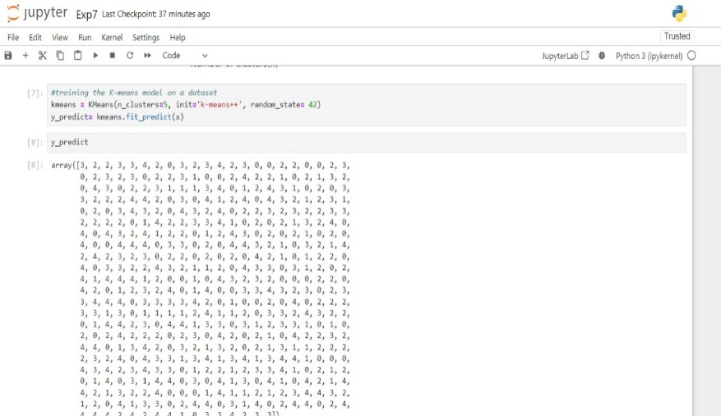

Step 5: This will display a scatter plot with data points coloured based on their assigned clusters.

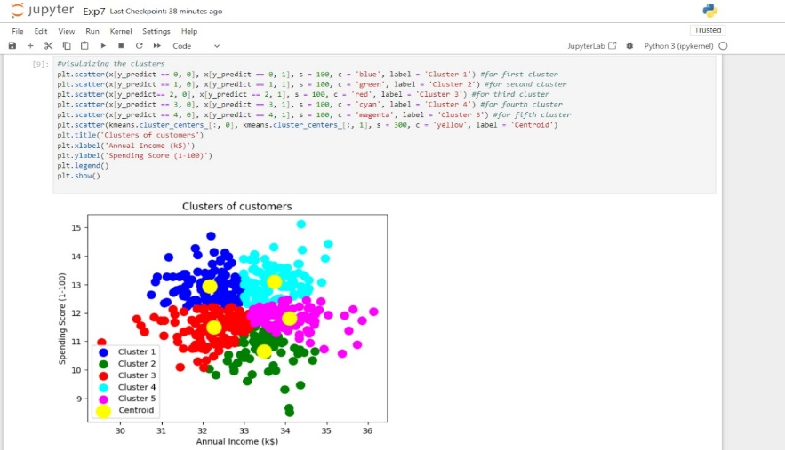

**Conclusion:**Hence we implemented Clustering Algorithms using python.